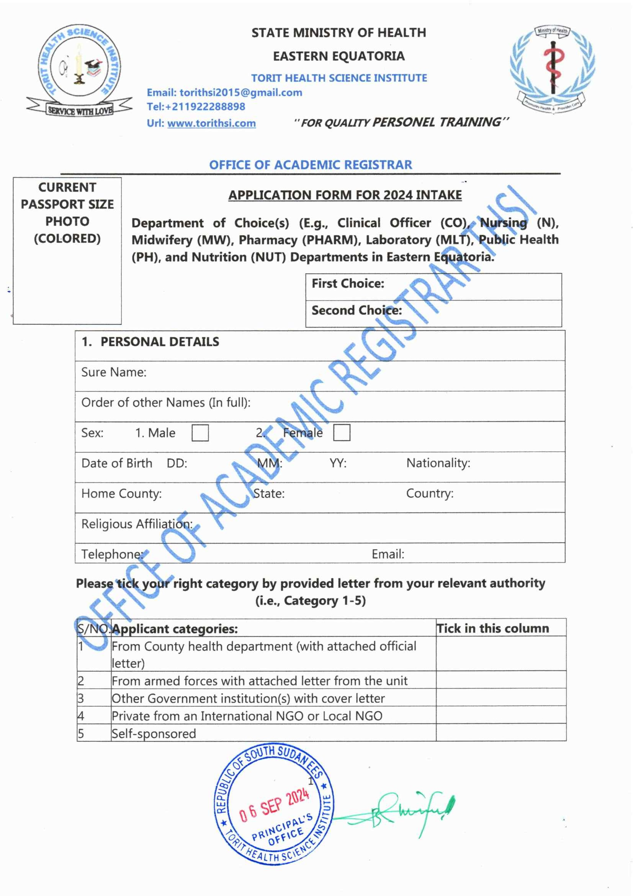
25 SEP 2025
APPLICATION FORM FOR 2026 INTAKE

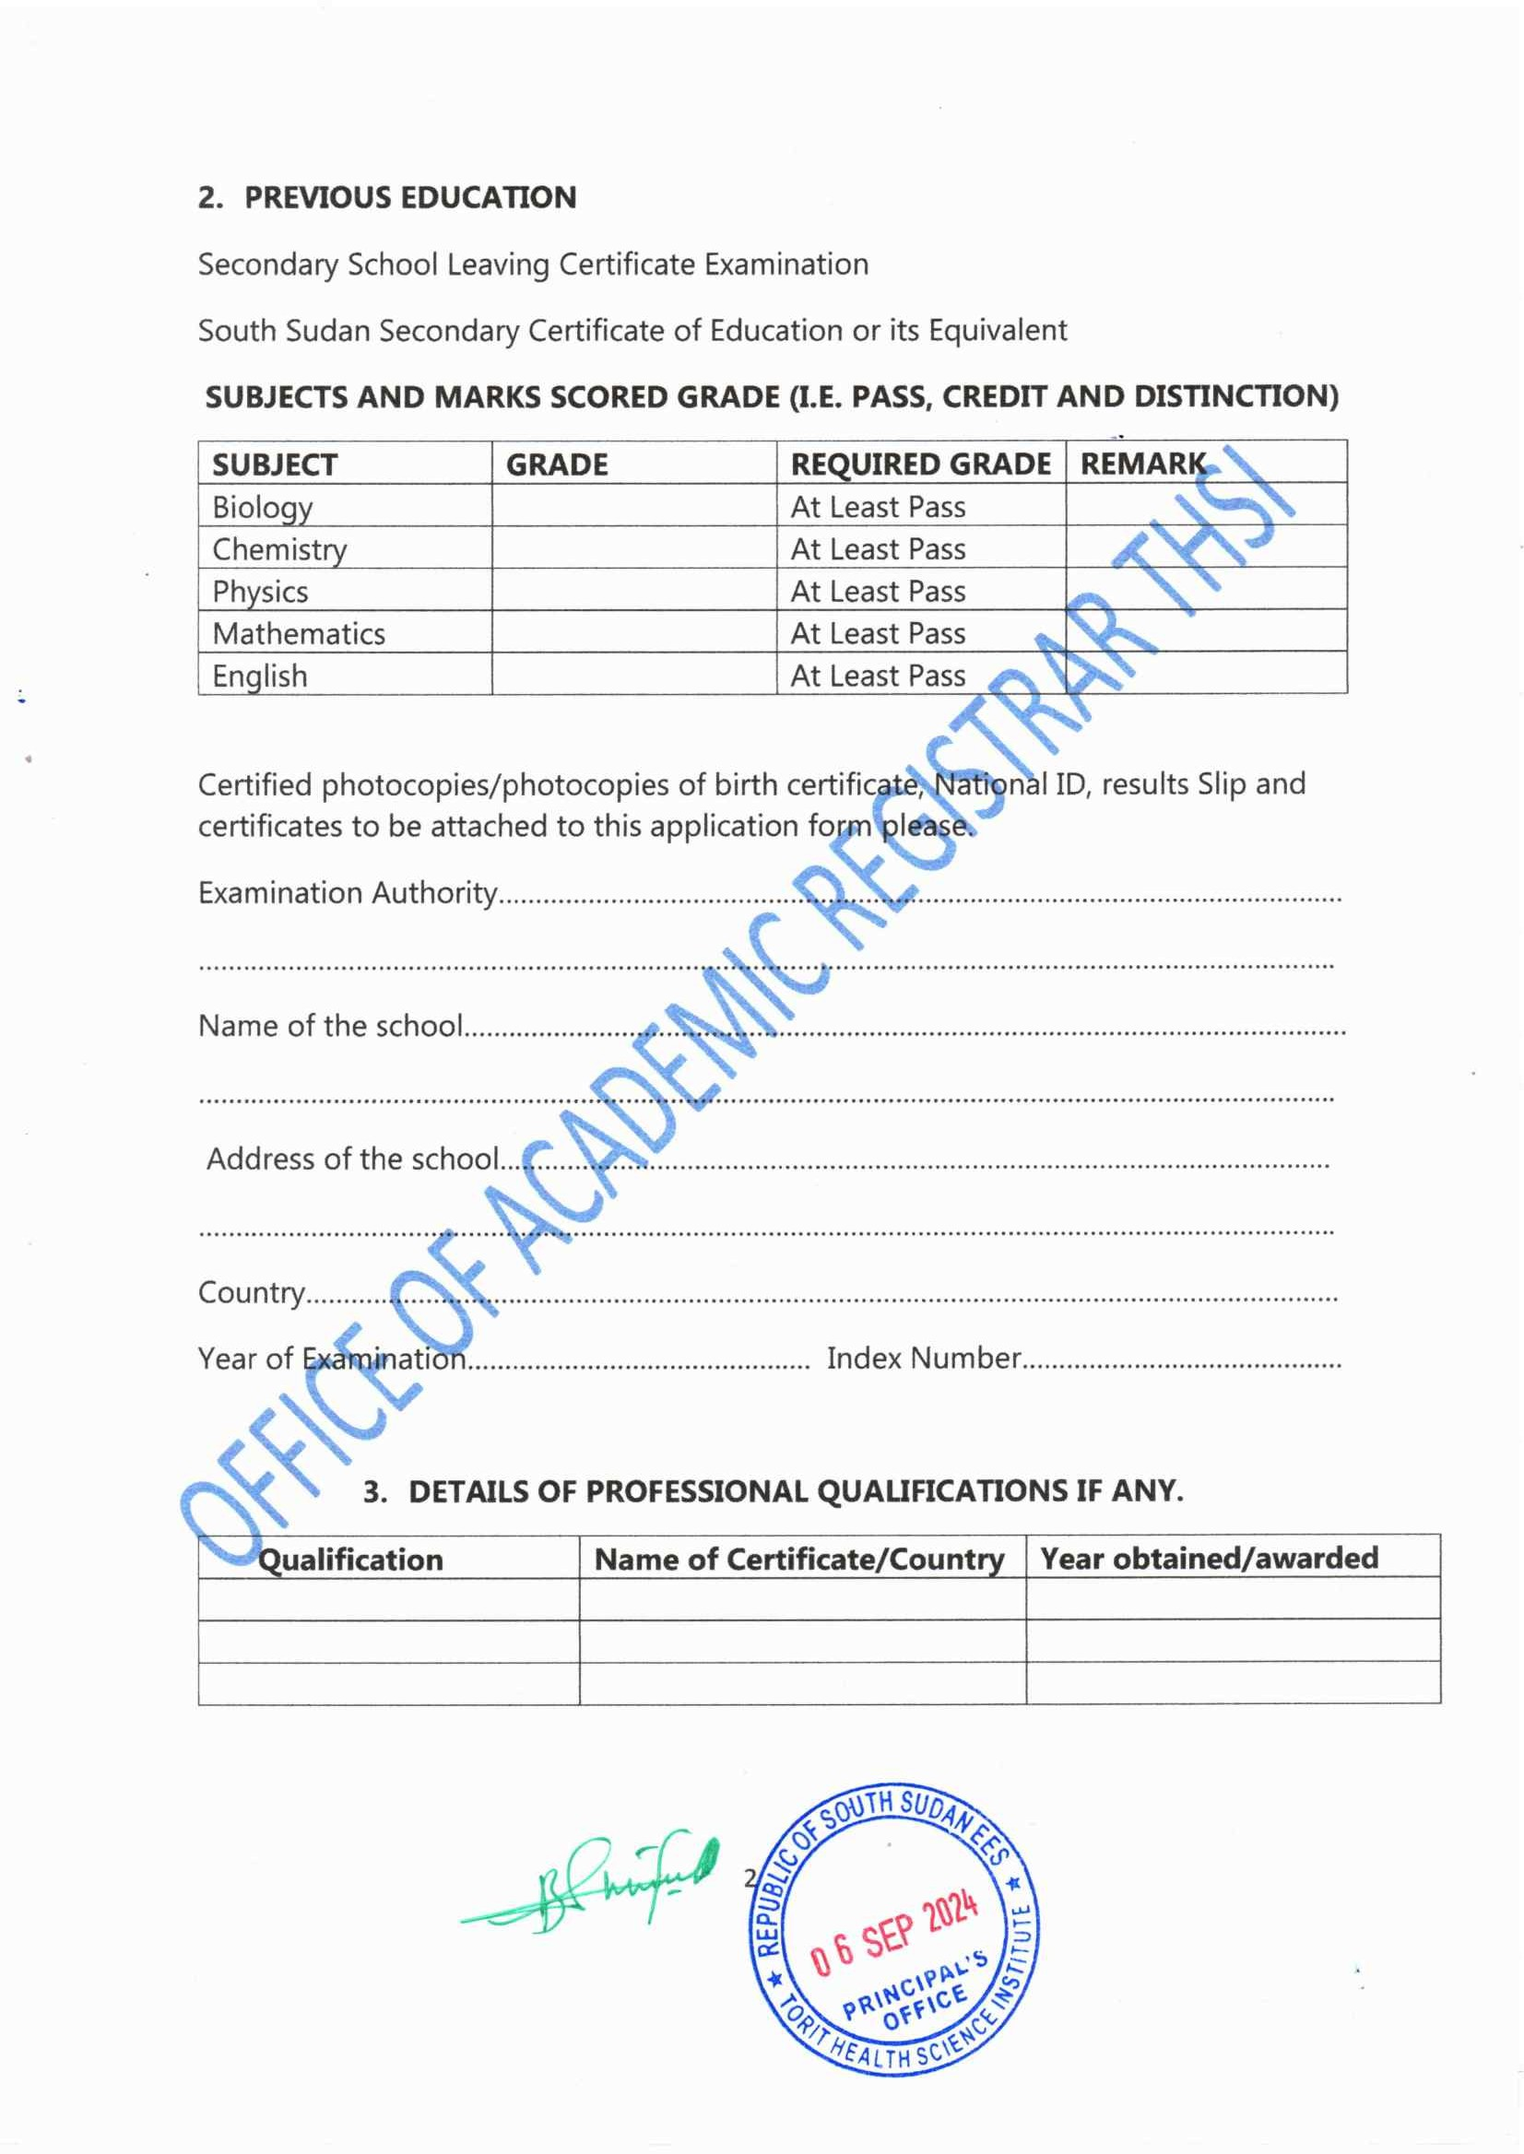
25 SEP 2025

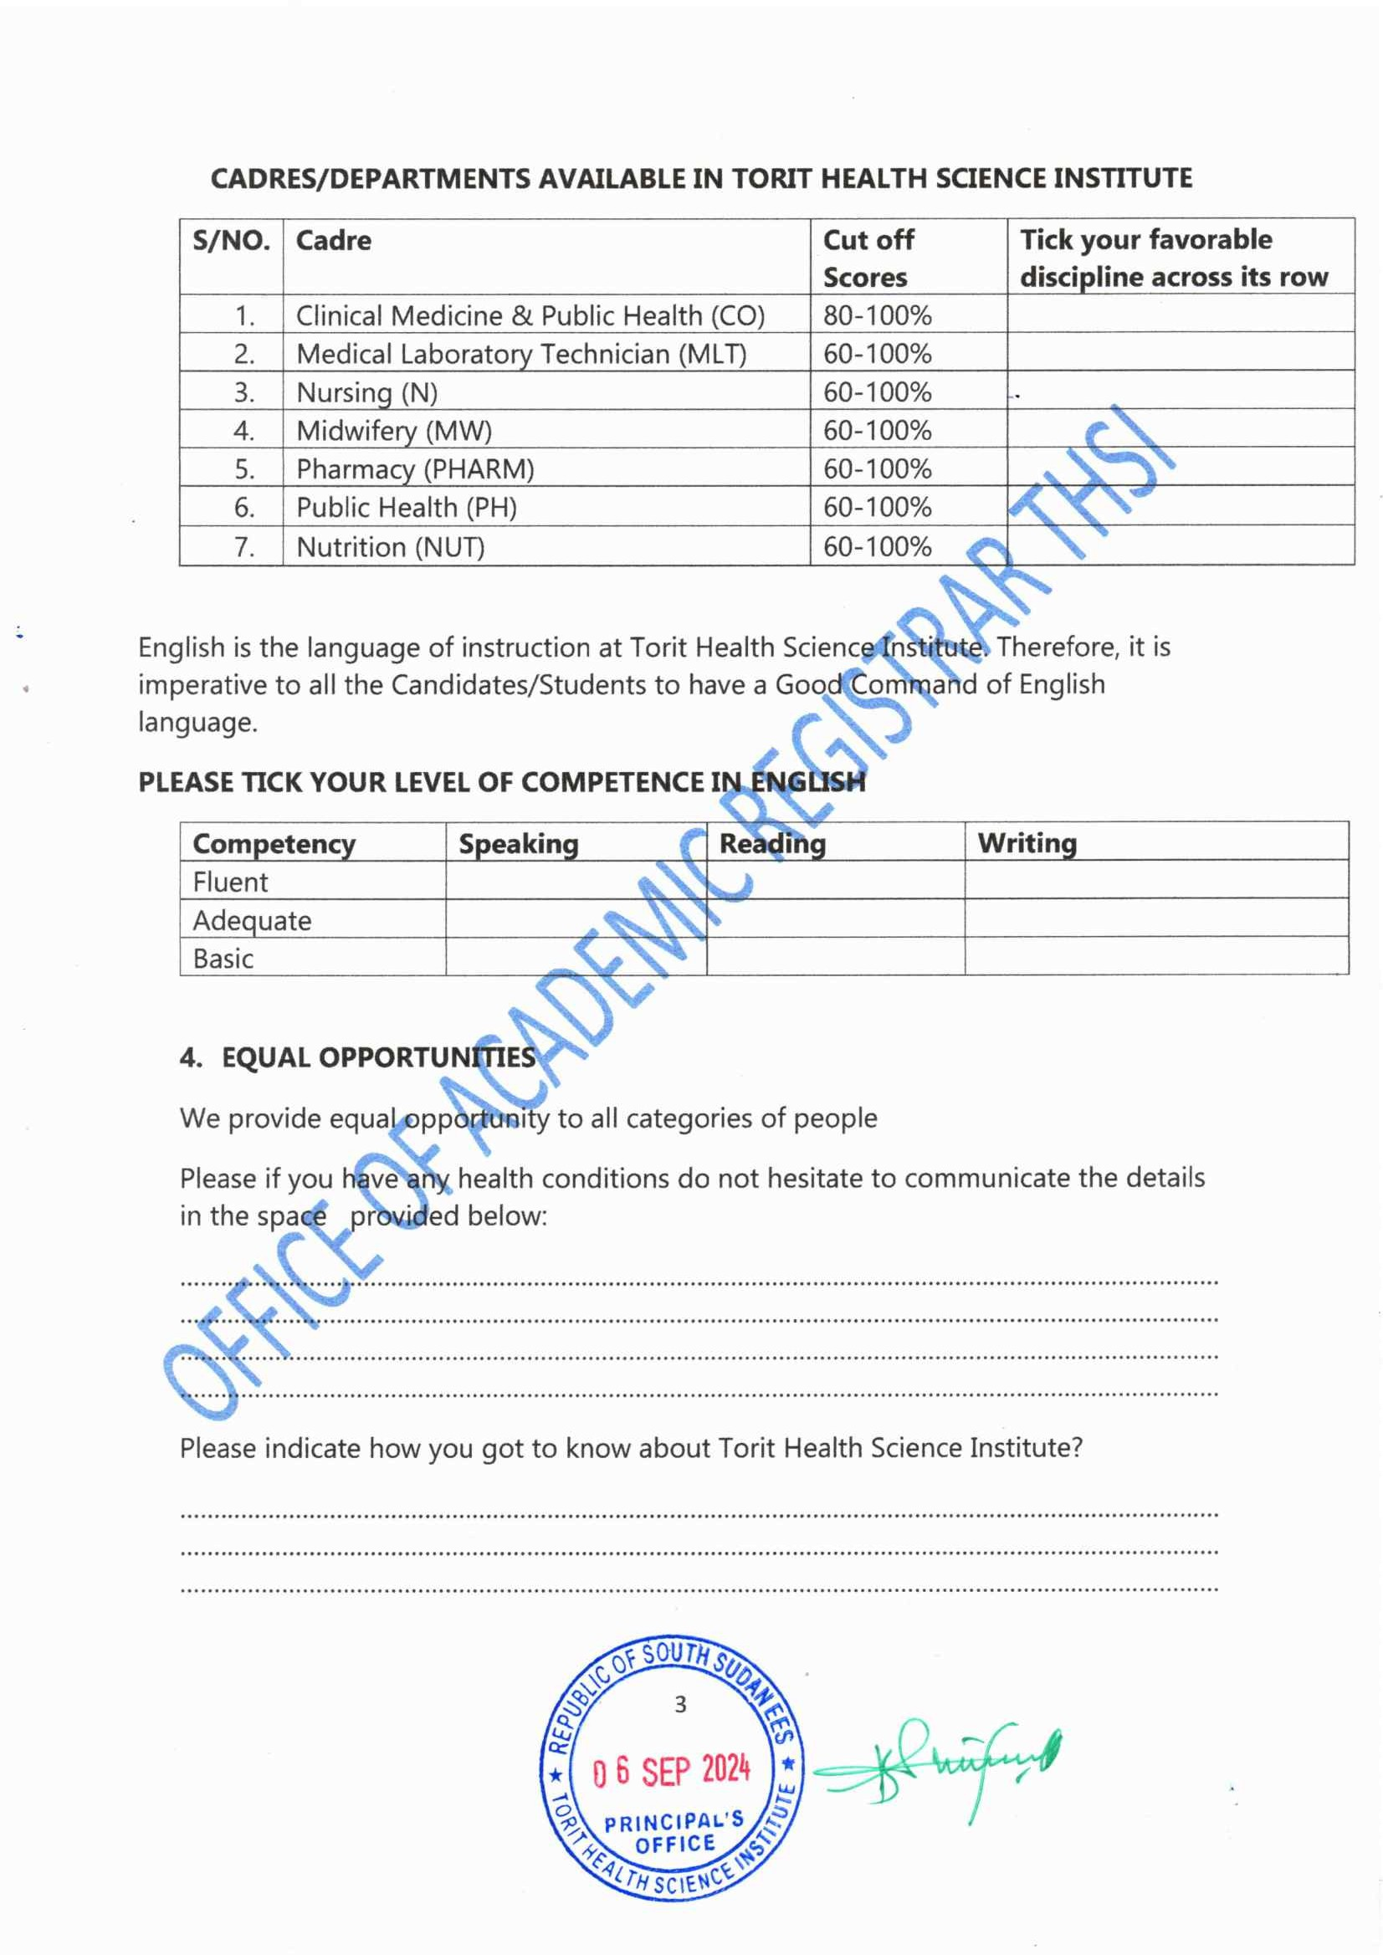
25 SEP 2025

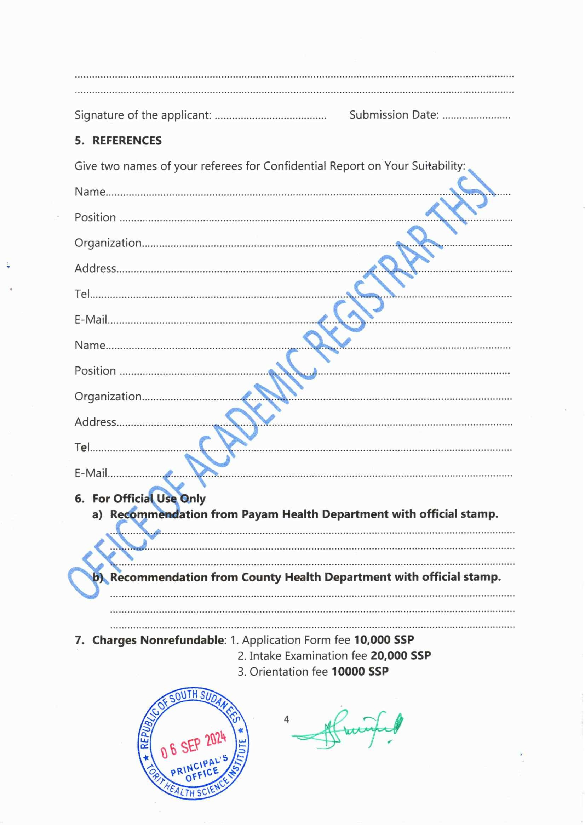
25 SEP 2025
2.Intake Examination Fee:50,000 SSP
3.Orientation fee:20,000 SSP
1.Application form fee:30,000 SSP

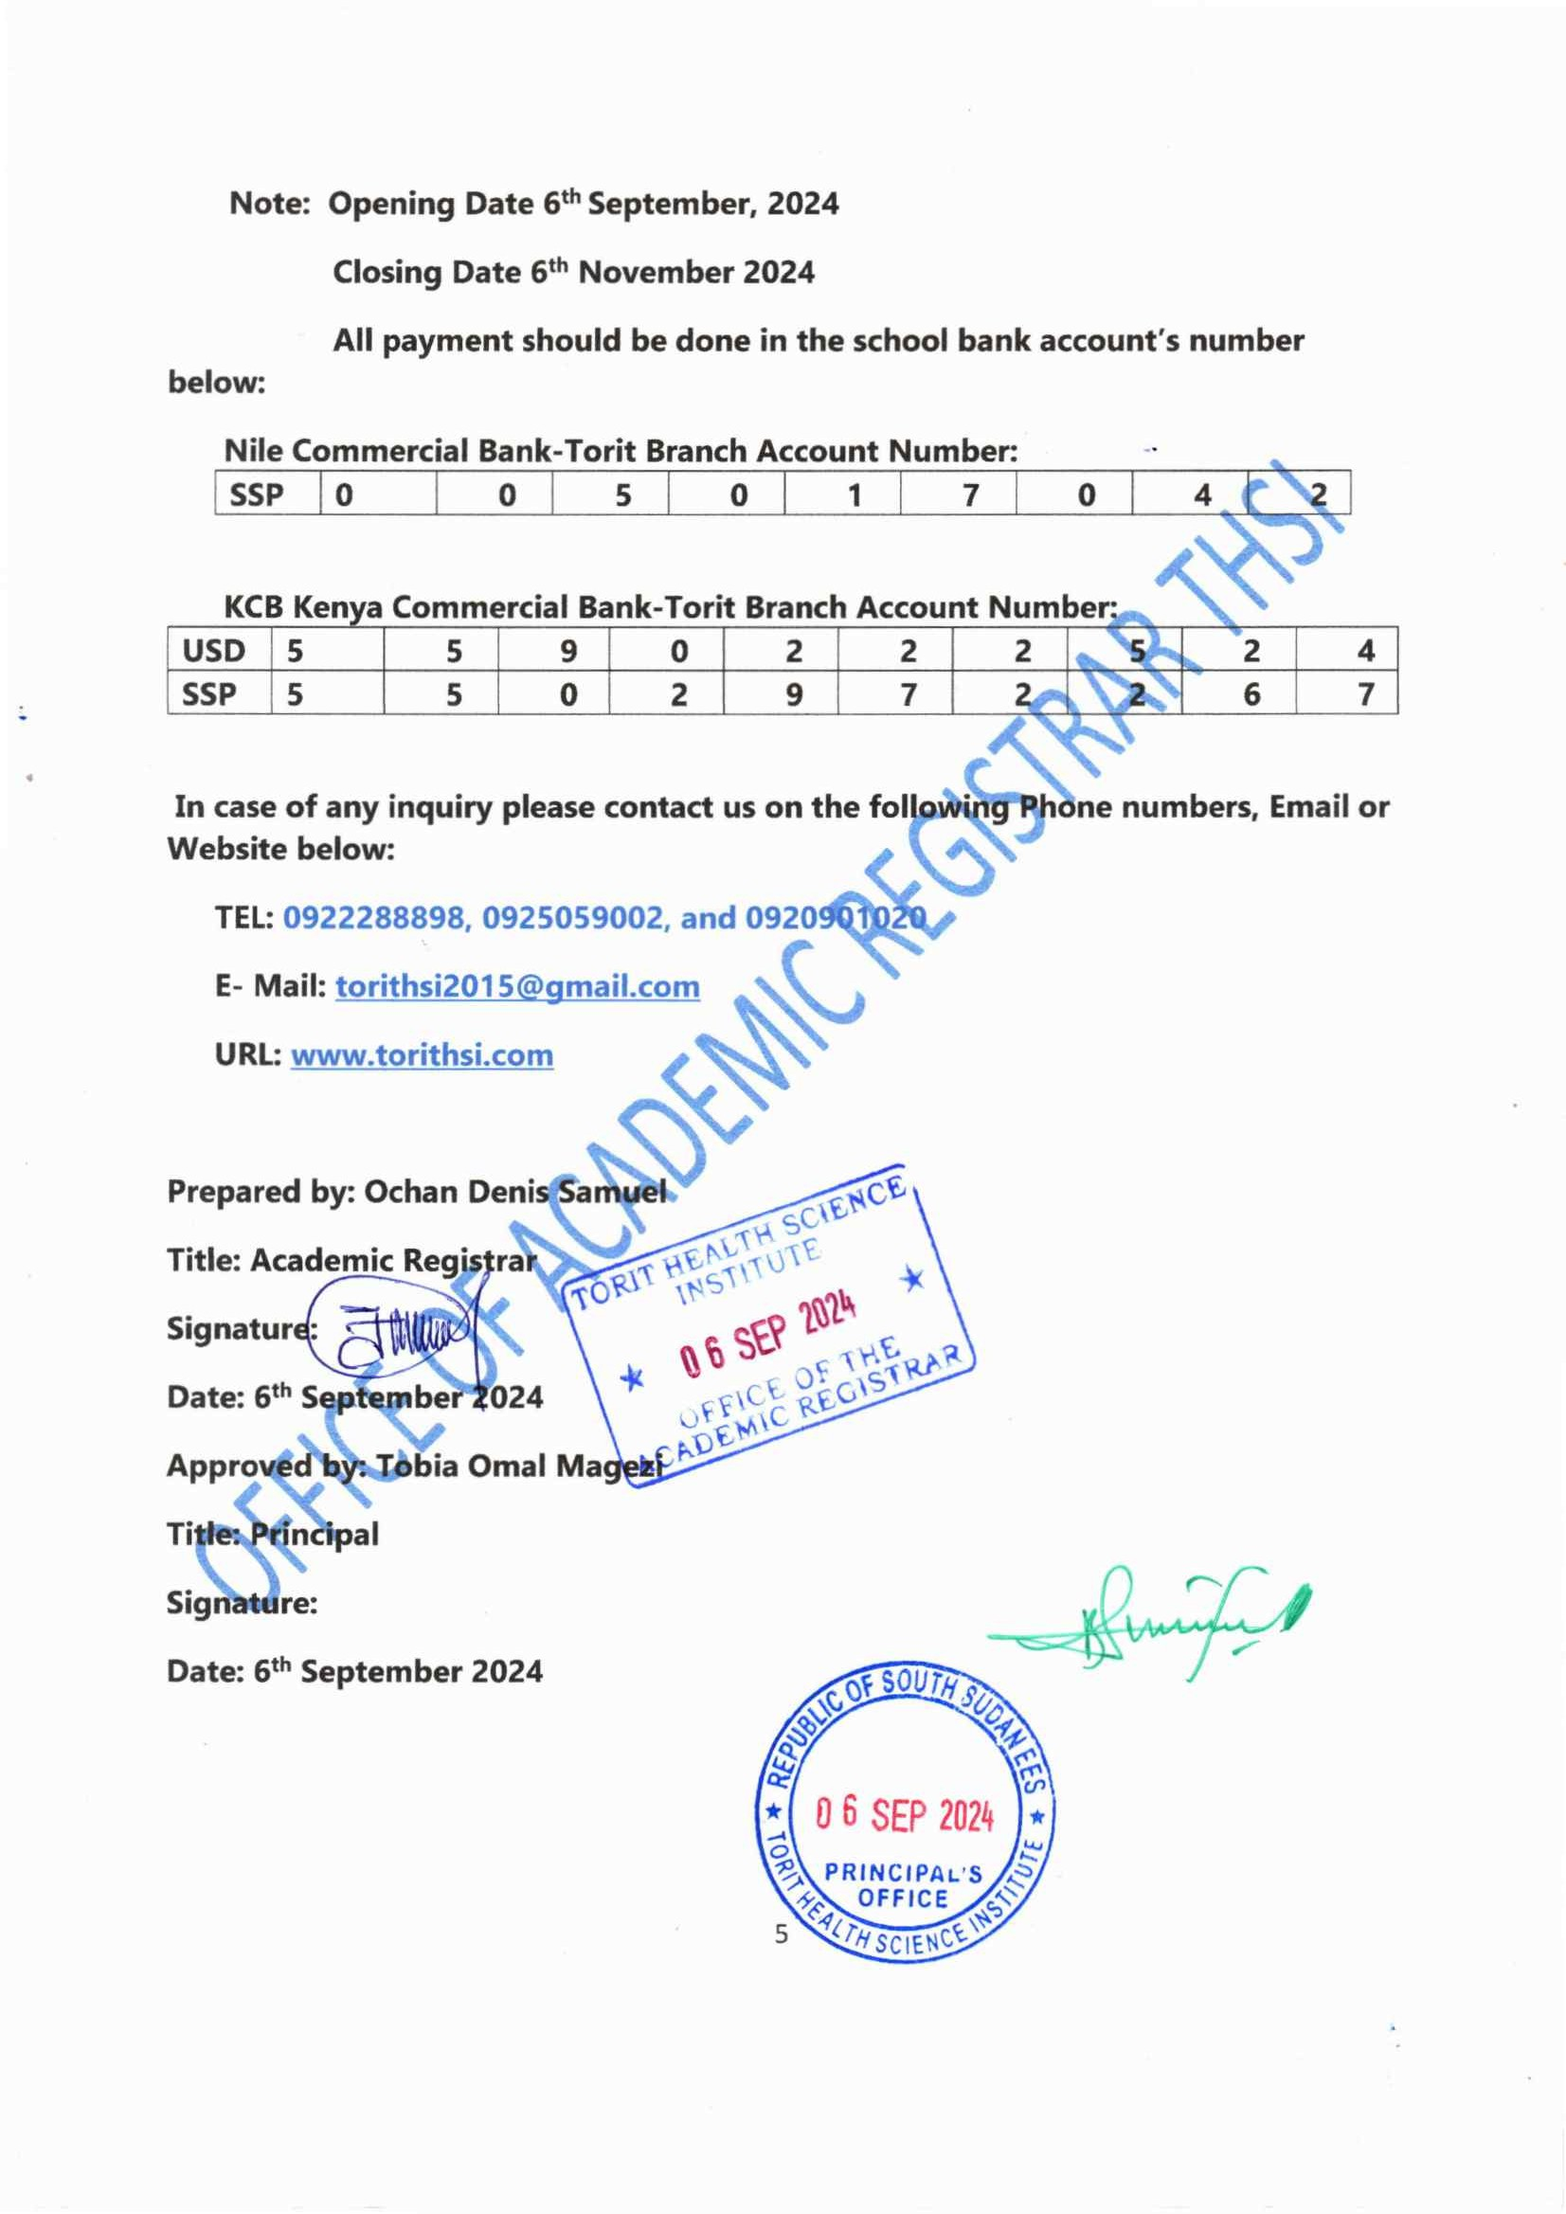
NOTE:
Semester one begins on: 5th January 2026
Opening Date For application: 25TH September 2025
Closing Date: 25TH September 2025
Display of results: 7th December 2025
Start of Entrance exam: 2nd December 2025
Orientation: 10th December 2025
25 SEP 2025

Date: 25th September 2025

Date: 25th September 2025
25 SEP 2025

